Appendix 1: Assignment submission cover sheet

**ASSIGNMENT SUBMISSION COVER SHEET**

|  |
| --- |
| BIDA22-068 |
| DEIRDRE GOUTA MMOLOTSA |
|  |
| Bida22-068@thuto.bac.ac.bw |

**Student Id:**

**Student names:**

**Student email**:

|  |  |
| --- | --- |
| Group4 |  |
| Deluxe Hotel Assignment | |

**Cohort**:

**Assignment title**:

|  |
| --- |
| 26 May 2023 |
|  |
| BSc (Hons) Business Intelligence and Data Analytics |

**Date of submission**:

**.**

**Programme of Study**:

|  |
| --- |
| Year 1 |

**Year of Study**:

**Intellectual property statement**

By checking the box below, I certify that this assignment is my own work and is free from plagiarism. I understand that the assignment may be checked for plagiarism by electronic or other means and may be transferred and stored in a database for the purposes of data-matching to help detect plagiarism. The assignment has not previously been submitted for assessment in any other unit or to any other institution. **I**

**have read and understood the Botswana Accountancy College plagiarism guidelines policy.**

☐ Agree



**Signature**…………………………………….



**Date**…26 May 2023……………………………………….

Deluxe Hotel can use technical feasibility analysis to determine the level and type of technology needed for the proposed computerized system. This includes assessing the hardware and software requirements, internet connectivity, and security systems as well as compatibility with existing systems, and the degree to which integration is required. Sources of risks are evaluated, and solutions are hypothesized to see if the goal of developing/building a computerized system for its operations is achievable.

Economic feasibility analysis is used to determine whether the system can be developed within the budget or not. Deluxe Hotel should conduct a cost-benefit analysis to identify how well or how poorly the system will be conclude which will help to determine the return on investment (ROI) and if the payback period is reasonable. The costs and benefits include development costs (the costs that occur when the system is built, for example, paying the programmers who are given the task to develop the system and operational costs (ongoing costs once the system is already in place. For example, continuing licensing and training). However, both tangible and intangible benefits are considered.

Deluxe Hotel must conduct a schedule feasibility analysis to arbitrate whether the development of the system can be done within a given time. It measures how reasonable the development of the system is. This deals with timeline estimations and optimization of resources within that time.

An Operational feasibility study can be performed to understand whether the proposal of the computerized system can solve Deluxe Hotel’s problems and improve management efficiency. The hotel should evaluate its existing processes and determine how they can be adapted to fit the new system. Hotel staff and management are determinants of the system’s operational feasibility in terms of well they adapt to changes.

a)

|  |  |  |  |
| --- | --- | --- | --- |
| **REQUEST FOR PROPOSAL** | | | |
| **REQUEST FOR PROPOSAL PROJECT NAME**  Request for Proposal for Deluxe Hotel | **PROPOSAL DUE**  26 May 2023 | | **ORGANIZATION NAME**  Deluxe Hotel |
| **PROJECT OVERVIEW**  Deluxe Hotel has several departments, each lead by a supervisor who oversees all the activities that take place within them and eventually reports to the Hotel Manager. Each of these departments has a supervisor who is responsible for overseeing and managing reports brought in by hotel staff. This current manual system of hotel management is fully based on paperwork and in-person activities. There may be some problems or delays in allocating rooms and providing services with this kind of management system. The manual Deluxe Hotel management is hard and time-consuming. All the records kept in files may get torn out, lost, or get damaged due to water or fire and the calculations made by staff may not be accurate sometimes. And even transferring the records or finding records is a big problem and creates a mess. The manual system of room reservation is not effective, and it needs to be improved because customers must visit the hotel first and ask for available rooms then inspect those rooms then only if the customer like it, he/she will take the room or not and for all these processes cost a lot of time. The proposed computerized system is an online web-application that will provide a digital representation for the reservations and booking department, to automate the bookings and reservations department as the hotel has grown, making the reservations and bookings more than the clerks can manage manually. This will allow the hotel’s booking and reservation services to be accessed online, and that the information used to create and maintain Deluxe Hotel’s competitive strategy is secured and only accessed by hotel-registered users even when they are in remote areas. | | | |
| **PROJECT OBJECTIVES**   1. To capture and store data about the hotel such as reservation details, staff details, payment details, rooms, types and charges, customer details, services, etc. 2. To provide a fast and efficient reservation and registration service. 3. To Record customer details. 4. To authorize the hotel staff to have access to the records and allow customers to be able to reuse their details to make bookings again (allow full accessibility to returning customers). 5. To display available rooms and their prices. 6. To inform the availability of rooms in real-time. 7. To provide the ability to reserve rooms anytime from anywhere with the internet. | | | |
| **DELIVERABLES**   1. A Fully functional web-based Application 2. System documentation 3. Learning, Training, and support for hotel staff on how to use the new system. | | | |
| **PROJECT DUE DATE**  20 June 2023 | | **ESTIMATED BUDGET**  P900 000 | |
| **CONTACT INFORMATION**  E-mail: [Bida22-068@thuto.bac.ac.bw](mailto:Bida22-068@thuto.bac.ac.bw)  Phone: +267 73515867  Physical Address: Private Bag 5628, CBD, | | | |

b**) Requirements**

**Functional:**

* The system should send confirmation message upon making reservations and payments.
* It should capture and store reservation details such as booking date, Expected Check-in, and Check-Out date, time, and other related customer information.
* The system should display the hotel the room’s rates.
* The system should be able to apply the 10% discount to the total according to specified rates.
* The system should check the validity of login details.
* The system should automatically cancel bookings if payment is not made within 3 days of making a reservation.

**Non-functional:**

* Accessibility- The system should make sure that information is accessed easily through public web pages.
* Customers should be able to enter their details (insertion and verification of details)
* The system should be easy to use.
* security- the computerized system must make sure that starategic and critical information about Deluxe hotel is only accessed by hotel-registered users. It should also make sure that customers’ details and payment information are kept safe.

**3. DESIGNING THE NEW SYSTEM**

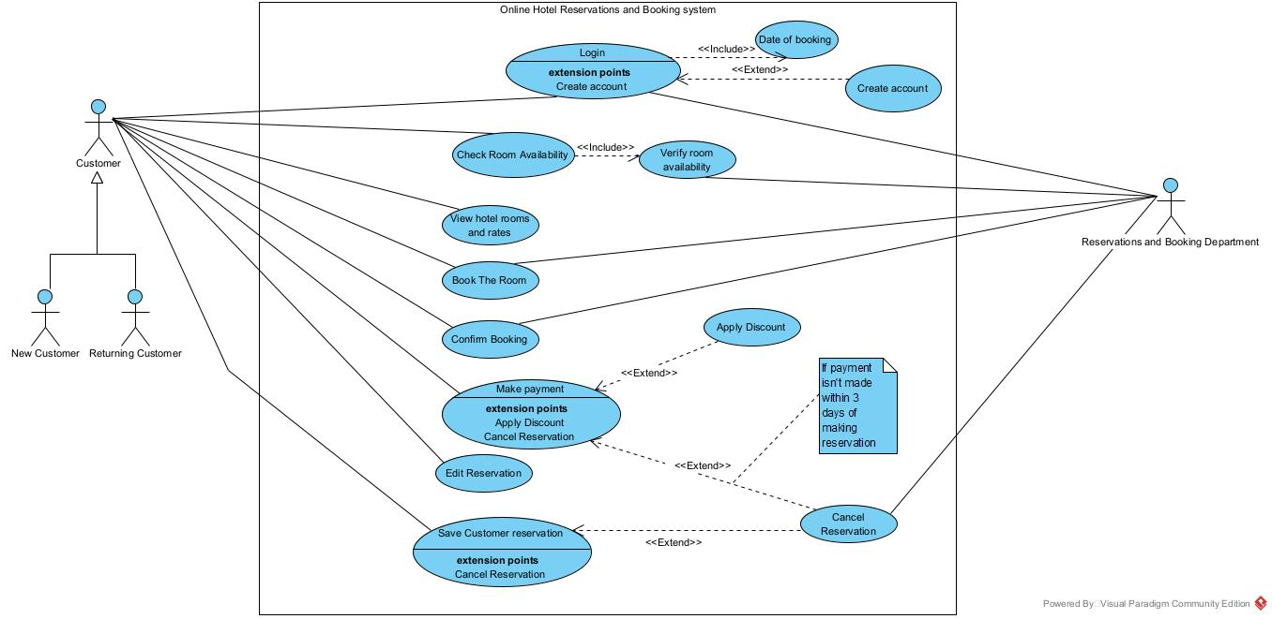

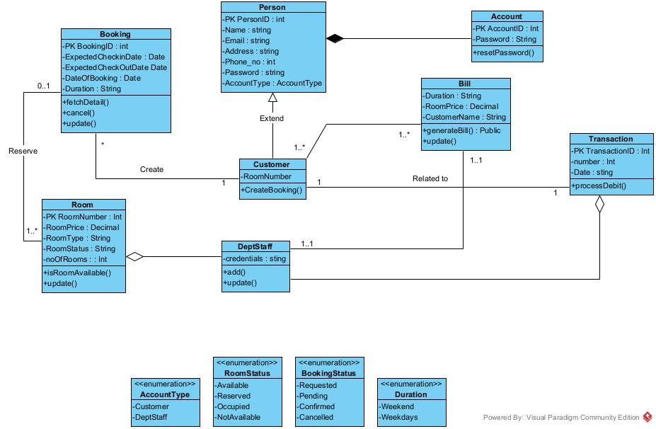

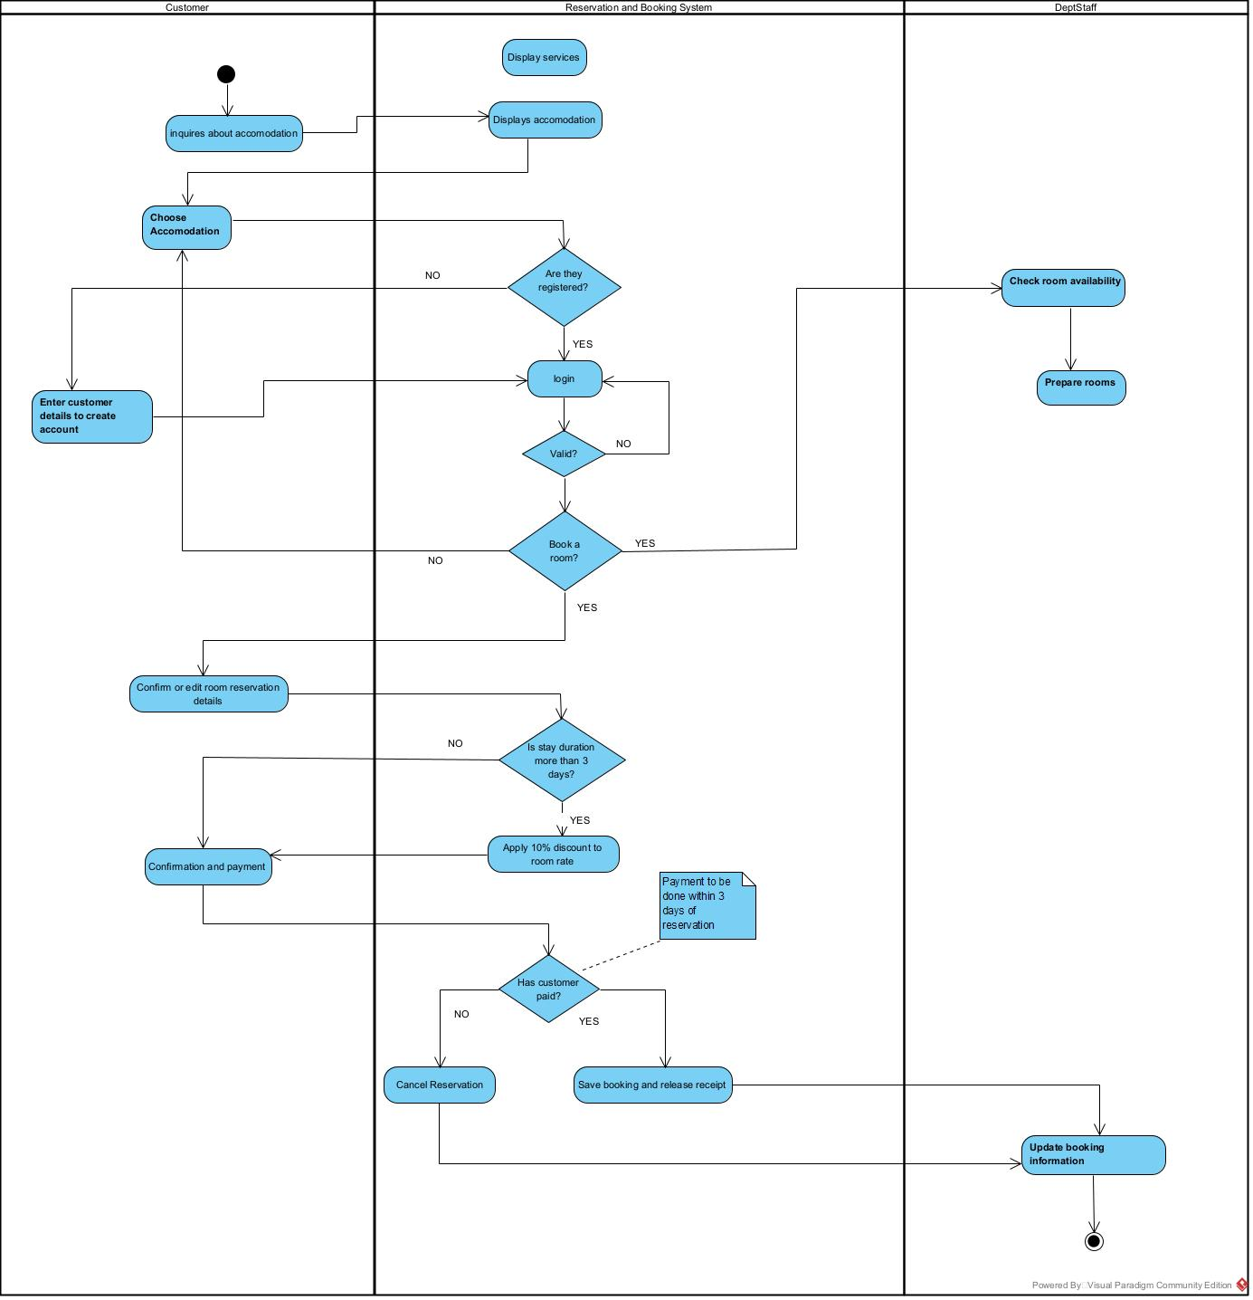

1. **IMPLEMENTATING THE NEW SYSTEM ( LOGICAL DESIGN**

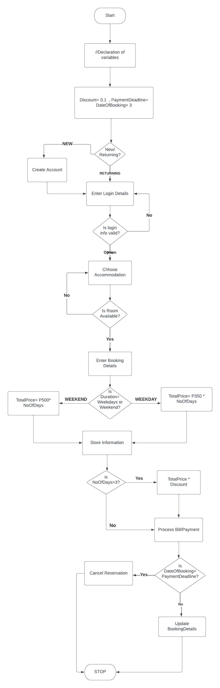

b) Pseudocode solution:

1. START
2. //declare variables
3. Date ExpectedCheckInDate, ExpectedCheckoutDate, DateOfBooking
4. Time Time
5. Int NoOfRooms
6. Decimal TotalPrice, DiscountedTotalPrice, Discount
7. Date, Time, Int AvailableRooms, Time, ReservedRooms, DateOfBooking
8. String Reserved, Duration, BookingDetails
9. Int NoOfDays
10. //Initialise values
11. Discount = 0.1
12. PaymentDeadline = DateOfBooking + 3
13. PRINT (“Please Enter log in details”)
14. ExpectedCheckInDate = PRINT(“Please Enter check-in date (DD-MM-YYYY):”)
15. ExpectedCheckOutDate = PRINT(“Please Enter check-out date (DD-MM-
16. YYYY):”)
17. NoOfDays = ExpectedCheckOutDate – ExpectedCheckInDate
18. AvailableRooms = get_available_rooms(
19. CheckInDate, CheckOutDate, Time, NoOfRooms)
20. NoOfRooms = PRINT(“Enter number of rooms needed: “)
21. IF NoOfRooms <= AvailableRooms
22. THEN Reserved = reserve_room(ExpectedCheckInDate,
23. ExpectedCheckOutDate, Time)
24. IF Duration = Weekdays
25. THEN TotalPrice = P350 * NoOfDays
26. IF NoOfDays > 3
27. THEN DiscountedTotalPrice = TotalPrice* Discount
28. PRINT (“Your Bill is: DiscountedTotalPrice”)
29. ELSE
30. PRINT (“Your Bill is: TotalPrice”)
31. ENDIF
32. ELSEIF Duration = Weekends
33. THEN TotalPrice = P500* NoOfDays
34. ENDIF
35. Function
36. processPayment(BookingDetails, TotalPrice, DiscountedTotalPrice)
37. As String
38. IF DateOfBooking> PaymentDeadline THEN
39. cancelBooking(Booking)
40. Return (“Reservation Cancelled)
41. ELSE
42. UpdateBooking(BookingDetails)
43. Return (“paid”)
44. End Function
45. ELSE
46. PRINT (“Sorry there are no rooms available”)
47. ENDIF
48. STOP

**5.Reviewing the new solution**

a).

|  |  |  |  |  |  |  |
| --- | --- | --- | --- | --- | --- | --- |
| ID | TASK | DEPENDENCE | EXPECTED TIME  (ET) | EARLIEST FINISH TIME (EF) | LATEST FINISH TIME  (LF) | CRITICAL ACTIVITY (yes/No) |
| 1 | Requirements | - | 10 | 10 | 10 | Yes |
| 2 | Analysis | 1 | 8 | 18 | 18 | Yes |
| 3 | Documentation | 1 | 15 | 44 | 25 | No |
| 4 | Logical Design | 2 | 6 | 24 | 24 | Yes |
| 5 | Report Design | 4 | 4 | 28 | 29 | No |
| 6 | Form Design | 4 | 5 | 29 | 29 | Yes |
| 7 | Implementation | 5,6 | 15 | 44 | 44 | Yes |
| 8 | Installation | 3,7 | 3 | 47 | 47 | Yes |

**c) based on DFD table abouve**